

**Polling District and Polling Place Review 2025**

**Throckley, Walbottle and Newburn Ward**

**Parliamentary Constituency:** Hexham | Central and West

**(Proposed) Polling Districts:** V01, V02, V03, V04, V05, V06

The Local Government Boundary Commission for England are an independent body accountable to Parliament. They are responsible for reviewing councils to make sure their patterns of internal wards are fair and sensible. Their reviews include at least two rounds of public consultation before they make recommendations for change.

The final recommendations were published on 7 January 2025, and the new arrangements apply to local elections from 2026.

As a result of changes to ward boundaries the Acting Returning Officer (ARO) is conducting a review of polling districts and polling places to ensure that they are suitable for the new ward boundaries.

For more information on the local government boundary review visit: <https://www.lgbce.org.uk/all-reviews/newcastle-upon-tyne>

This document provides details of the review, along with the initial recommendations and comments of the Acting Returning Officer (ARO). Also, the election rules require the ARO to decide how many polling stations are required for each polling station and the ARO must allocate electors to the polling stations in such manner as they think most convenient.

These recommendations will be open to all residents, stakeholders, and any interested parties. We shall be seeking representations from local disability groups on the accessibility and suitability of polling places. Any comments should be addressed in the first instance to pollingplaces@newcastle.gov.uk where they will be collated on behalf of the (Acting) Returning Officer.

We considered the following factors:

* **Identifying new polling places:** We will look for new polling places in areas where the existing provision is unsuitable or unavailable.
* **Feedback:** We will consider feedback received following recent elections, consultation from members of the public, elected members, and other stakeholders.
* **Accessibility:** We will try to ensure that every polling place is accessible to electors with disabilities.
* **Facilities**: We will make sure that all electors have such reasonable facilities for voting as are practicable in the circumstances.
* **Elector numbers:** We will try to comply with the Electoral Commission guidance on the maximum number of electors that should be allocated to a polling station which should not exceed 2,250.
* **Future housing developments**: We will consider the impact of proposed housing developments on polling station electorates.

**(Current) Callerton & Throckley**

This map shows the current ward and polling district boundaries and the polling places.

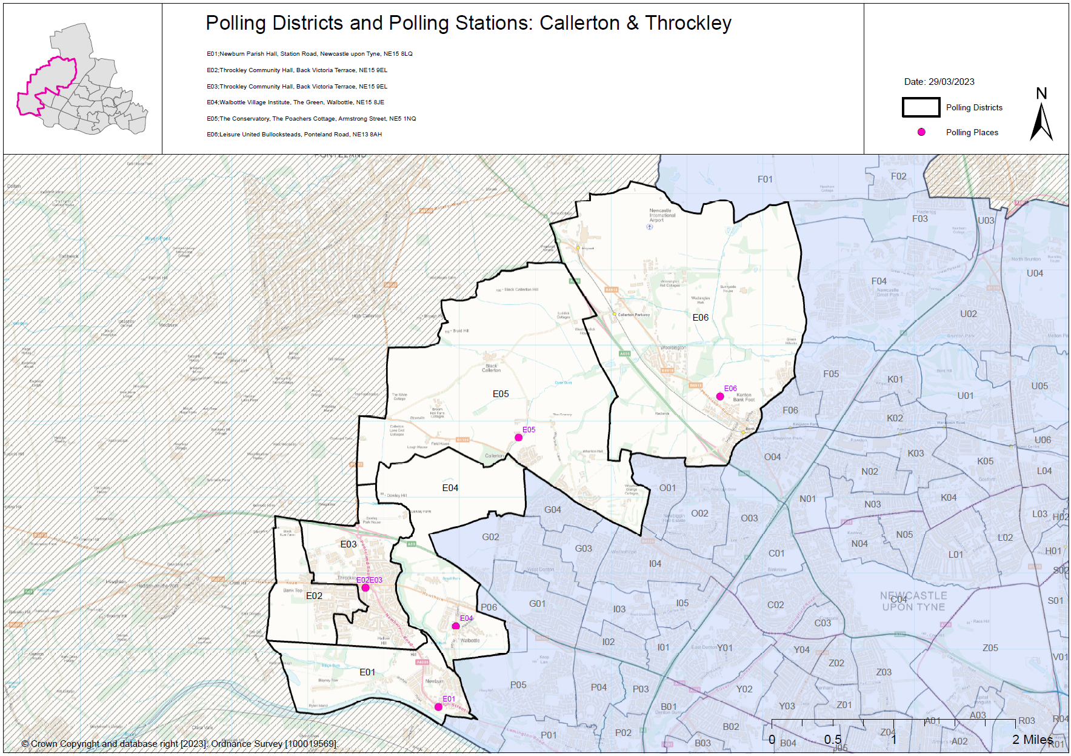

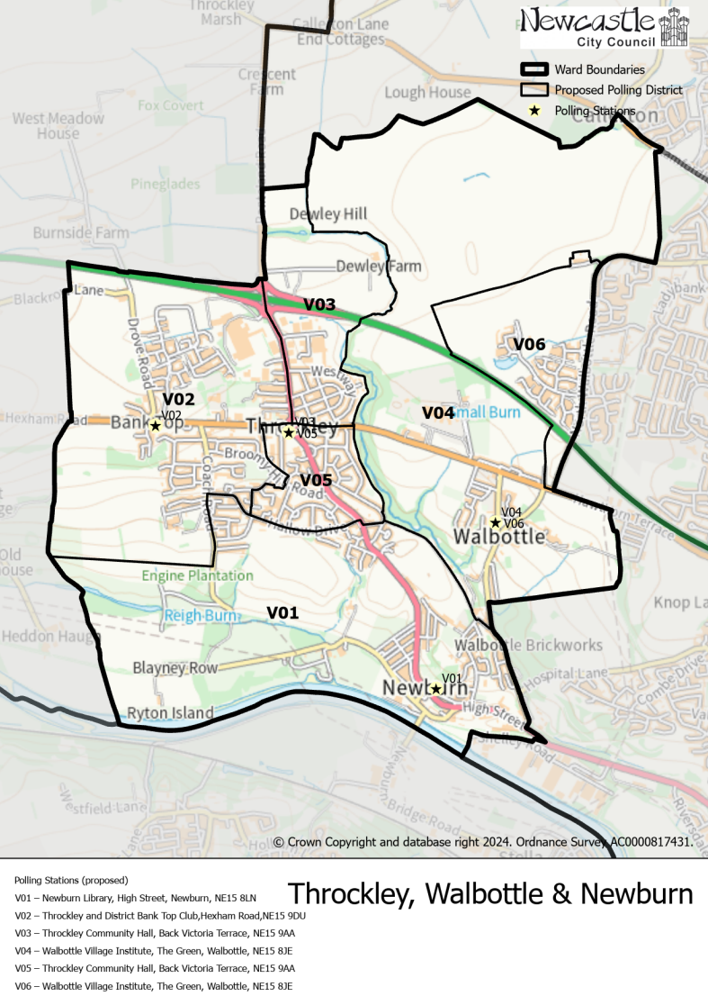**(New)**

**Throckley, Walbottle and Newburn Ward**

This map shows the new ward and the proposed polling districts and the proposed polling places.

* **V01**

Newburn Library, High Street, Newburn, NE15 8LN

* **V02**

Throckley and District Bank Top Club, Hexham Road, NE15 9DU

* **V03**

Throckley Community Hall, Back Victoria Terrace, NE15 9AA

* **V04**

Walbottle Village Institute, The Green, Walbottle, NE15 8JE

* **V05**

Throckley Community Hall, Back Victoria Terrace, NE15 9AA

* **V06**

Walbottle Village Institute, The Green, Walbottle, NE15 8JE

**Throckley, Walbottle and Newburn Ward**

**Polling District V01**

|  |
| --- |
| **Considerations and Proposals** |
| Current E01 district and part of the current E03 district would merge to form the proposed V01 district. Properties south of Hallow Drive would now form the proposed V01 district.    Newburn Library is within the district and is an internal building therefore a potentially cheaper option; however, Newburn Parish Hall is also still an option as it is within the new district. Site visit has been carried out on 1 August 2025 and awaiting confirmation that we can use the building. |

|  |  |
| --- | --- |
| **Current Polling District** | **Current Polling Place** |
| E01 (full)  E03 (part of) | Newburn Parish Hall, Station Road, NE15 8LS  Throckley Community Hall, Back Victoria Terrace, NE15 9AA |

|  |  |  |
| --- | --- | --- |
| **Proposed Polling District** | **Predicted**  **Polling Station Electorate** | **Proposed Polling Place** |
| V01 | 1245 | Newburn Library, High Street, Newburn, NE15 8LN |

|  |
| --- |
| **Preliminary Consultation – Elected Members comments and feedback** |
| No comments received. |

**Throckley, Walbottle and Newburn Ward**

**Polling District V02**

|  |  |
| --- | --- |
| **Current Polling District** | **Current Polling Place** |
| E02 (full)  E03 (part of) | Throckley Community Hall, Back Victoria Terrace, NE15 9AA  Throckley Community Hall, Back Victoria Terrace, NE15 9AA |

|  |  |  |
| --- | --- | --- |
| **Proposed Polling District** | **Predicted**  **Polling Station Electorate** | **Proposed Polling Place** |
| V02 | 1337 | Throckley and District Bank Top Club, Hexham Road, NE15 9DU |

|  |
| --- |
| **Considerations and Proposals** |
| Current E02 and part of the current E03 districts would merge to form the proposed V02 district. The boundary line at Drove Road has been removed to continue along to Ponteland Road, forming the proposed V02 district.  Throckley and District Bank Top Club is the suggested building to be used for this district. Site visit was carried out on the 12 August 2025 and the building was deemed suitable for use. |

|  |
| --- |
| **Preliminary Consultation – Elected Members comments and feedback** |
| No comments received. |

**Throckley, Walbottle and Newburn Ward**

**Polling District V03**

|  |  |
| --- | --- |
| **Current Polling District** | **Current Polling Place** |
| E03 (part of) | Throckley Community Hall, Back Victoria Terrace, NE15 9AA |

|  |  |  |
| --- | --- | --- |
| **Proposed Polling District** | **Predicted**  **Polling Station Electorate** | **Proposed Polling Place** |
| V03 | 429 | Throckley Community Hall, Back Victoria Terrace, NE15 9AA |

|  |
| --- |
| **Preliminary Consultation – Elected Members comments and feedback** |
| No comments received. |

|  |
| --- |
| **Considerations and Proposals** |
| Part of the current E03 would form the proposed V03 district. Properties to the east of Ponteland Road, to Hexham Road in the south, would form the proposed V03 district.  No change to the polling place. Throckley Community Hall is suggested as a double polling station for the proposed districts of V03 and V05. |

**Throckley, Walbottle and Newburn Ward**

**Polling District V04**

|  |  |
| --- | --- |
| **Current Polling District** | **Current Polling Place** |
| E04 (full) | Walbottle Village Institute, The Green, Walbottle, NE15 8JE |

|  |  |  |
| --- | --- | --- |
| **Proposed Polling District** | **Predicted**  **Polling Station Electorate** | **Proposed Polling Place** |
| V04 | 383 | Walbottle Village Institute, The Green, Walbottle, NE15 8JE |

|  |
| --- |
| **Considerations and Proposals** |
| Current E04 would become the proposed V04. No change to the polling district boundary.  No change to the polling place. Walbottle Village Institute is suggested as a double polling station for the proposed districts of V04 and V06. |

|  |
| --- |
| **Preliminary Consultation – Elected Members comments and feedback** |
| No comments received. |

**Throckley, Walbottle and Newburn Ward**

**Polling District V05**

|  |  |
| --- | --- |
| **Current Polling District** | **Current Polling Place** |
| E03 (part of) | Throckley Community Hall, Back Victoria Terrace, NE15 9AA |

|  |  |  |
| --- | --- | --- |
| **Proposed Polling District** | **Predicted**  **Polling Station Electorate** | **Proposed Polling Place** |
| V05 | 787 | Throckley Community Hall, Back Victoria Terrace, NE15 9AA |

|  |
| --- |
| **Considerations and Proposals** |
| Part of the current E03 would form the proposed V05 district. Properties south of Hexham Road and north of Hallow Drive would form the proposed V05 district.  No change to the polling place. Throckley Community Hall is suggested as a double polling station for the proposed districts of V03 and V05. |

|  |
| --- |
| **Preliminary Consultation – Elected Members comments and feedback** |
| No comments received. |

**Throckley, Walbottle and Newburn Ward**

**Polling District V06**

|  |  |
| --- | --- |
| **Current Polling District** | **Current Polling Place** |
| G02 (part of)  P06 (part of) | Chadca Centre, Hanover Close, NE5 1EG  Blucher Methodist Church, Blucher Terrace, NE15 9SH |

|  |  |  |
| --- | --- | --- |
| **Proposed Polling District** | **Predicted**  **Polling Station Electorate** | **Proposed Polling Place** |
| V06 | 347 | Walbottle Village Institute, The Green, Walbottle, NE15 8JE |

|  |
| --- |
| **Considerations and Proposals** |
| Part of the current G02 and P06 districts would merge to form the proposed V06 district.  Walbottle Village Institute is an existing polling place and meets accessibility requirements.  There are no other suitable alternatives within the proposed district. It is suggested to use this polling station as a double station for the proposed V04 and V06 districts. |

|  |
| --- |
| **Preliminary Consultation – Elected Members comments and feedback** |
| Councillor Linda Wright and Councillor Marc Donnelly are happy with the proposal of Walbottle Village Institute. |